**K230593**

**Muhammad Ayesh**

**Lab-05 DSA**

**Backtracking**

**Task-01**

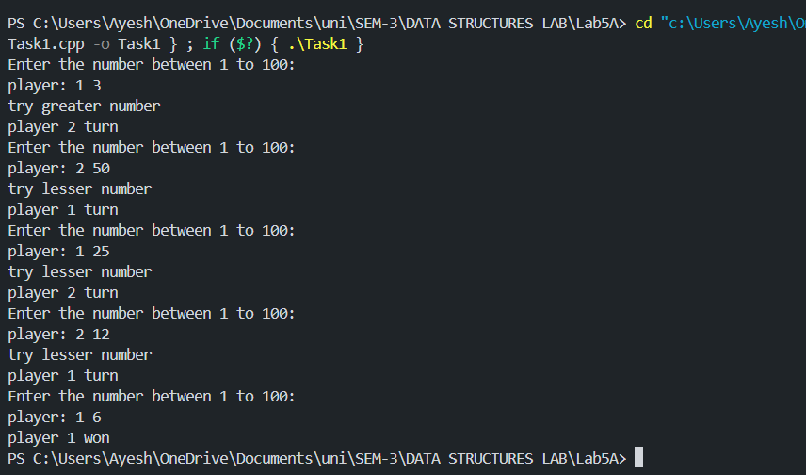

**Task-02**

**Task-03**

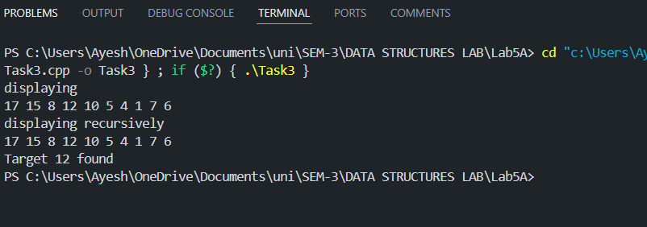

**Task-04**

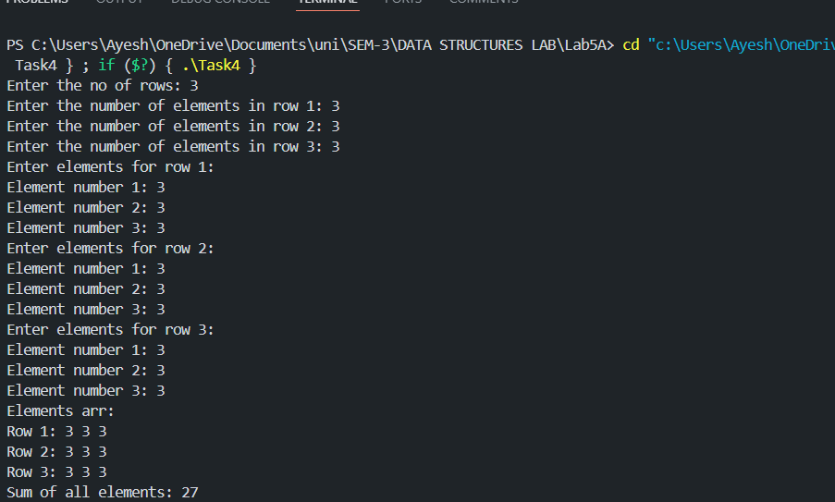

**Task-5**

**Task-6**

